***NFC-Based Attendance System Using Students’ Phones***

In the era of digital transformation, traditional attendance systems are being replaced by more efficient and convenient solutions. Leveraging Near Field Communication (NFC) technology, our project introduces a modern approach to attendance tracking by harnessing the power of students' smartphones.

**Problem Statement:**

Conventional attendance methods often suffer from inaccuracies, inefficiencies, and time-consuming processes. Manual methods such as paper-based registers or card swiping systems are prone to errors and can be easily manipulated. Moreover, they require significant administrative effort and do not provide real-time insights into attendance patterns.

**Solution Overview:**

Our solution addresses these challenges by employing NFC-enabled smartphones as unique identification tokens. When students enter the classroom, they simply tap their phones on an NFC reader installed at the entrance, instantly registering their attendance.

**Key Features:**

Efficiency: Streamlines the attendance process, saving valuable instructional time and reducing administrative burden.

Accuracy: Eliminates the possibility of proxy attendance or manual errors, ensuring precise attendance records.

Convenience: Utilizes students' smartphones as their identification tokens, eliminating the need for additional hardware or cards.

Real-time Monitoring: Provides educators and administrators with instant access to attendance data, facilitating proactive intervention and analysis.

Scalability: Easily scalable to accommodate varying class sizes and educational institutions of all levels.

**Current System Setup:**

The current setup involves NFC readers that capture the unique identifiers (UIDs) from students' smartphones and transmit this data to a Google Sheet for real-time attendance tracking.

**Required Components:**

**Hardware Components:**

1. ESP8266
2. RFID RC522
3. BREADBOARD
4. WIRES
5. NFC ENABLED SMARTPHONE

**Software Components:**

1. ARDUINO IDE
2. GOOGLE SHEETS
3. ANDROID STUDIO (FOR FURTHER APPLICATION)

**Circuit Diagram:**

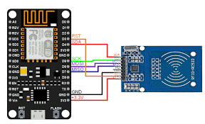

**Workflow:**

1. **Student Interaction:**

Students tap their NFC-enabled smartphones on the NFC reader at the classroom entrance.

1. **Data Transmission:**

The NFC reader captures the UID and transmits it to the connected Google Sheet.

1. **Data Logging:**

The Google Sheet logs the UID along with a timestamp, recording the attendance event.

**Result:**

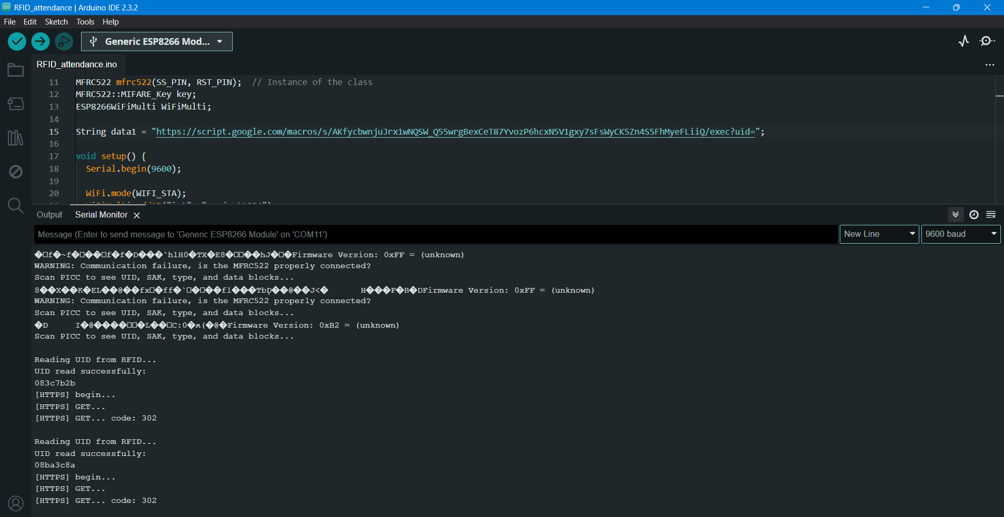

Serial printing the process

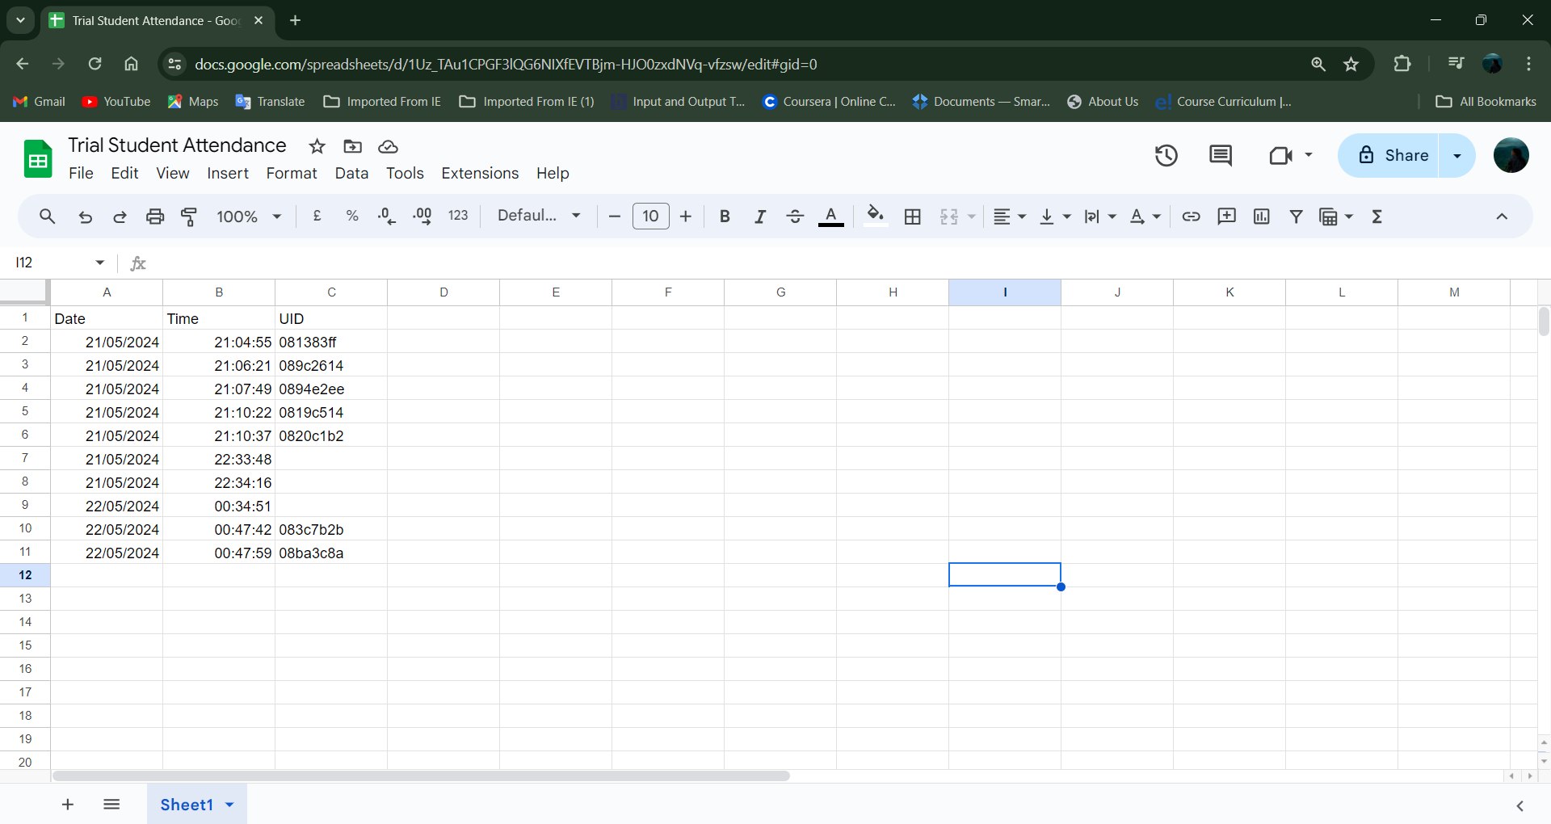

Uploaded uid in the google sheet

Benefits:

1. Efficiency:

Quick and seamless attendance logging.

1. Real-time Data:

Immediate availability of attendance records.

1. Scalability:

Easy to set up additional NFC readers for other classrooms.

**Future Enhancements:**

The future development of the system will include the creation of a dedicated mobile app to transmit more specific data, such as student names and IDs, enhancing the functionality and user experience.

**Planned Components:**

**Mobile Application:**

A dedicated app for students' smartphones that will store and transmit detailed attendance data. Transmits comprehensive information (student name, ID, etc.) to the NFC reader.

**Enhanced Data Transmission:**

Modifications to NFC readers to accept and process more detailed data from the mobile app.

**Advanced Attendance Management Software:**

Software to replace Google Sheets for more robust attendance data management. Includes features such as report generation, data analytics, and integration with existing school management systems.

**Conclusion:**

Our NFC-based attendance system represents a significant step forward in modernizing attendance tracking in educational institutions. The current setup, utilizing NFC readers and Google Sheets, provides a reliable and efficient solution. Future enhancements, including the development of a dedicated mobile app and advanced management software, will further improve the system's functionality, security, and user experience. By continuing to innovate and adapt, we aim to create a state-of-the-art attendance tracking system that meets the evolving needs of schools and universities.

*File attached with used codes and assembly video.*